Year of the Rat

Read the assignment and write down the answers in English. You may use English-language Internet sources to help you. If you only know the Dutch word, use a dictionary to find the English word.

In China, each year carries the name of an animal. There are 12 animals, which come back in a fixed order each Chinese New Year. 2020 is the Chinese Year of the Rat. Did you know that rats can giggle and sing?

Before reading:

a 2020 is the Chinese Year of the Rat. What are the other 11 Chinese New Year animals? Look it up and write them down.
b Find a picture of each of the Chinese New Year animals.

___________________________________________________________________________

10 facts about rats!

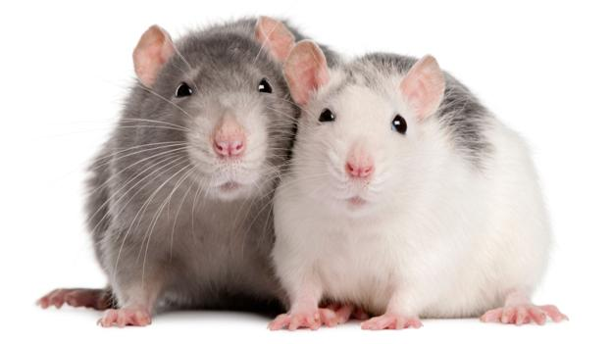
2020 is the Chinese Year of the Rat…
The rat is the first of a 12-year cycle of animals that appears in the Chinese Zodiac, so if you were born in 2008, you were born in a rat year, too. Chinese astrologers say that means you’re funny, smart, successful, are a quick thinker and welcome challenges. Read more about Chinese New Year in our 30 cool facts about China.
1) Rats are medium-sized rodents with a long tail. A group of rats is called a ‘mischief’!
2) Rats are mainly nocturnal and live underground. Although they vastly outnumber humans, we rarely see them. They are experts at staying out of sight!
3) Throughout human history, rats have travelled with us around the planet, stowing away on boats and settling wherever humans live. They feed on the food we throw away and can spread diseases among humans, like the medieval Black Death, which was spread by fleas that lived on rats.
4) Rats’ super-strong teeth never stop growing! They have to keep nibbling to wear them down – or eating would become impossible!
5) Their whiskers are more sensitive than human fingertips! Rats brush the long hairs against objects or the floor, helping them build up a detailed picture of their environment.
6) With eyes on either side of their head that can move in opposite directions, rats are even able to see what’s happening above them. Very handy for spotting any rat-eating birds!
7) Rats can hear well, including sounds that are too high-pitched for humans to hear. They may also ‘smile’ with their ears! When they’re happy their ears relax, become droopy and slightly pinker. Aww!
8) They wash by constantly licking their fur – sometimes they’ll even ‘comb’ it into place with their teeth. Yes, rats are squeak-y clean!
9) Rats’ long tails are used for balance and to keep themselves cool – they can direct some of their body heat out through them! They’re also great swimmers, able to hold their breath for several minutes.
10) A single rat can leave 25,000 droppings a year – poo–ey!
___________________________________________________________________________
After reading:
Read the text. Connect the words and expressions in the two columns that have the same meaning.

- the Zodiac | a. active mainly during the night
- rodents | b. animal poo
- nocturnal | c. to be more in number than someone or something
- to outnumber | d. to clean something or make it smooth
- to stow away | e. completely different; to the other side
- fleas | f. de dierenriem
- whiskers | g. evenwicht
- to brush | h. to hide on a boat or airplane or other place
- opposite | i. to keep air in your lungs for a short time instead of breathing out
- high-pitched | j. long, stiff hairs that grow near the mouth of some animals
- to lick | k. making a high sound
- fur | l. to pass your tongue over something
- balance | m. small animals (such as mice, rats, etc.) with sharp front teeth
- to hold your breath | n. the hairy coat of an animal
- droppings | o. very small insects that live on animals, with strong legs used for jumping

Answer the multiple choice questions:

a What do they say about people born in a rat year?
1 People born in a rat year are called a ‘mischief’.
2 People born in a rat year are funny and smart.
3 People born in a rat year are good swimmers.
4 People born in a rat year are good swimmers.

b What do rats eat?
1 Birds.
2 Droppings.
3 Fleas that live on other rats.
4 Food that we throw away.

c Which facts about rats are true?
1 People have always kept rats as pets.
2 Rats can use their long tails to make sure that they do not fall.
3 Rats paint pictures on the floor with their long hairs.
4 Their teeth grow constantly.
5 There are more rats than people on earth.

